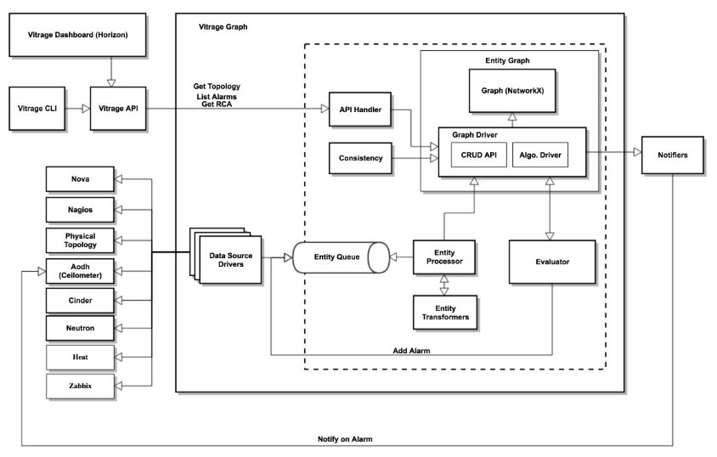

Vitrage provides a root cause analysis service, which is used for analyzing the topology and alarms of the cloud, and providing insights about it.

The Root Cause Analysis service consists of the following components:

**vitrage-graph service**

The main process. It holds the in-memory entity graph, the template evaluator, and the different datasources.

**vitrage-notifier service**

Used for notifying external systems about Vitrage alarms/state changes. It only calls Nova force-down API and Simple Network Management Protocol (SNMP) in the Ocata release.

**vitrage-api service**

The API layer for Vitrage.

Regarding the root cause of problems and deducing the existence of problems before they are directly detected. Its ultimate goal is that

|  |
| --- |
| metadata:  name: <unique template identifier>  description: <what this template does>  definitions:  entities:  - entity: ...  - entity: ...  relationships:  - relationship: ...  - relationship: ...  scenarios:  - scenario:  condition: <if statement true do the action>  actions:  - action: ... |

Interface:

1.topololy:

UI:

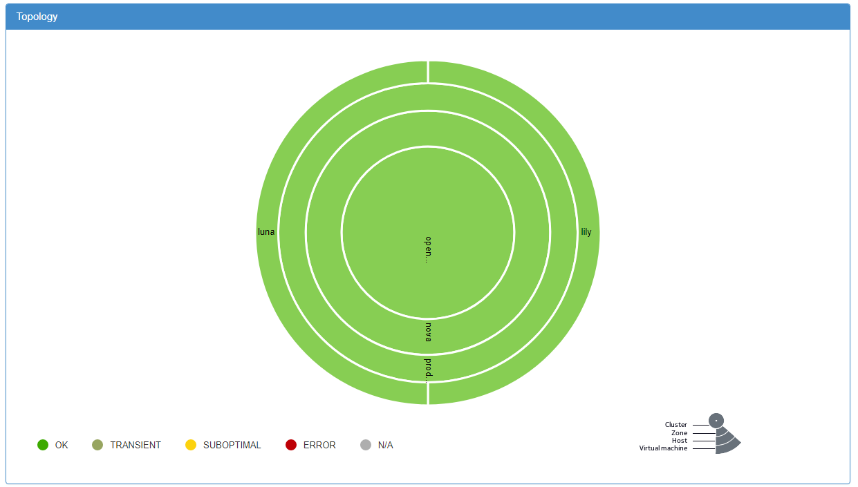

Hoạt dộng --- graph gan voi nhau  
(phần graph: chưa thể hiện rõ port nào, switch vật lý (chưa có cài đặt) như nào , nếu cài nhiều node???)

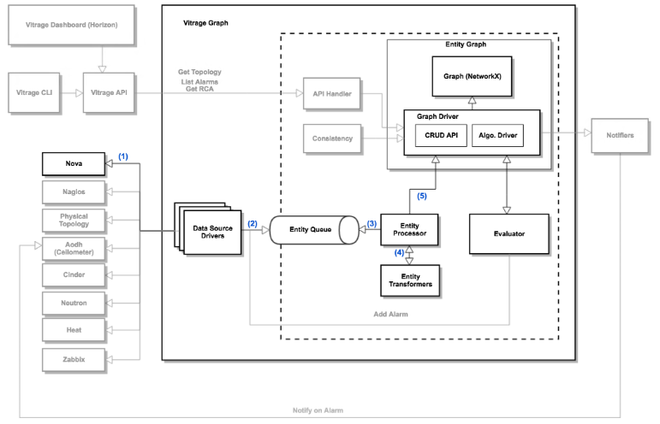

Khi nova thêm 1 instance:

<https://docs.openstack.org/vitrage/pike/contributor/vitrage-use-cases.html>

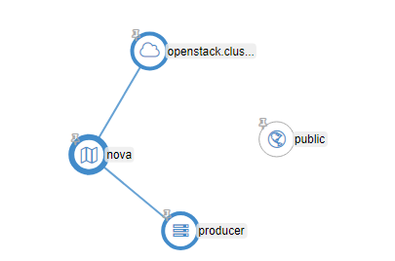

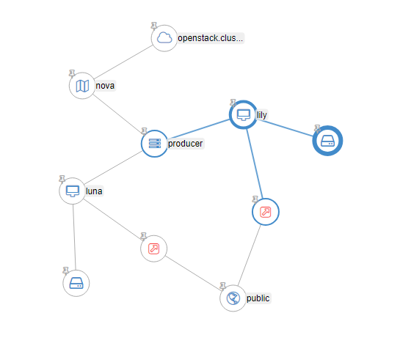

**Kết quả: zone nova có thêm 2 instance lily và luna, nó được cập nhật từ datasource nova, neutron. (Các hình mũi tên chỉ neutron port - hiện đang tắt)**

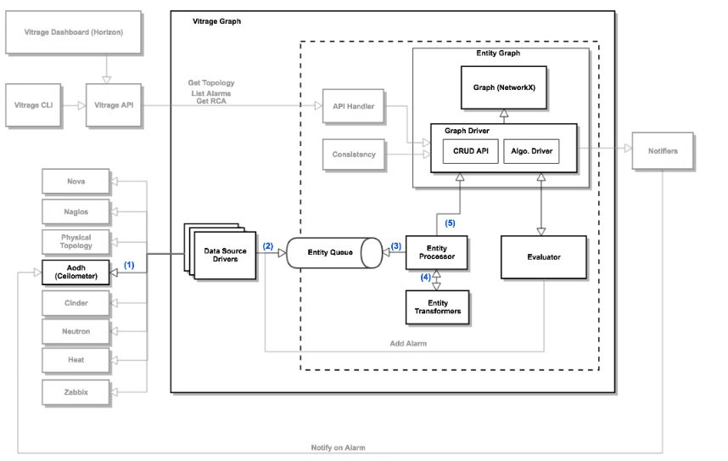

Khi aodh thêm alam:

Khi có nagios - zambix alam:

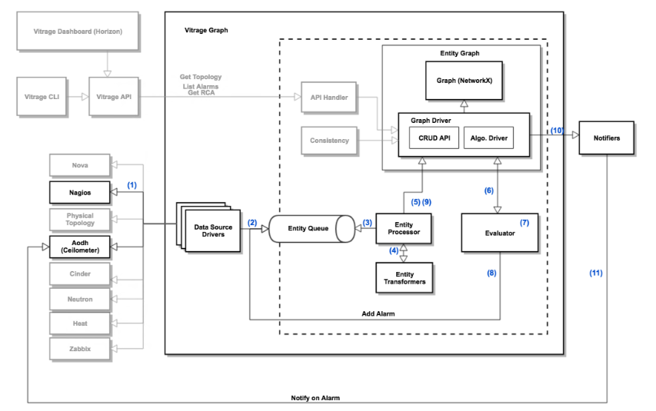

Evaluator + template gan voi nhau

van deo viet dc template viet tha nao aa!!!!!! wtf man

Resource:

